Wedding Song Revisited
July 30, 2016
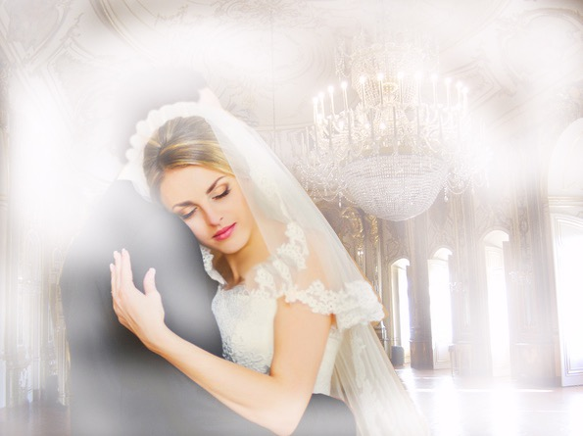
The sweet, sweet presence of our heavenly Bridegroom engulf you, dear Heartdwellers.

I just wanted to introduce this song. It's something that I had written quite a while ago, and it's already on the channel. But I figured a lot of people had probably missed it. And it was a song that I was inspired to write by my experience with the Lord as His Bride, dancing with HIm. In fact, the book Chronicles of the Bride that Ezekiel and I wrote, the first chapter of that book pretty well outlines the experience I had with him. And this song is very, very reminiscent.

So, it's following on the heels of the other message about His heavenly Brides. So, I hope you enjoy it. The Lord bless you with this tender vision, and help you to understand that you truly are this dear to Him.

Oh, how beautiful you are My Bride, My Dove,
My heart is captivated by your love.
Angels dance beneath your veil,
Weaving Pearls within your hair.
Never have you been so fair, My Dove,
Never have I been so in love.

Oh, how lovely are your sandaled feet, My Bride,
How I’ve longed to have you with Me, by My Side.
Come to Me and give your hand,
I shall wed thee with this golden band.
Golden like the teardrops on your cheek,
You’ve won Me with your heart so meek.

Oh, how beautiful you are My Lord, My King,
How I’ve longed to give my hand and wear Your ring.
Heaven dances in Your eyes,
To be with You is Paradise.
Never have you been more fair, My Dove,
Never have I been so in love.

Oh, how precious is the tender love we share,
and the union of our hearts a gift so rare.
Bathed in graces from above,
Heaven celebrates our sweet love.
Never shall we drift apart, My Dove,
Forever you shall rest on My Heart.

Bathed in graces from above,
Heaven celebrates our sweet love.
Never shall we drift apart, My Dove,
Forever you shall rest on My Heart.

